YOLOv3 is the third improvement of the original model YOLO.

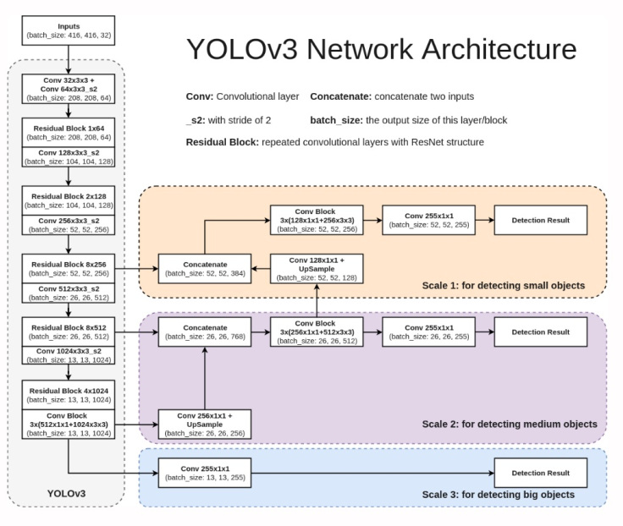

YOLOv3 is trained to recognize 80 classes of objects, which are:

person, bicycle, car, motorcycle, airplane,

bus, train, truck, boat, traffic light, fire hydrant, stop_sign,

parking meter, bench, bird, cat, dog, horse, sheep, cow, elephant, bear, zebra,

giraffe, backpack, umbrella, handbag, tie, suitcase, frisbee, skis, snowboard,

sports ball, kite, baseball bat, baseball glove, skateboard, surfboard, tennis racket,

bottle, wine glass, cup, fork, knife, spoon, bowl, banana, apple, sandwich, orange,

broccoli, carrot, hot dog, pizza, donot, cake, chair, couch, potted plant, bed,

dining table, toilet, tv, laptop, mouse, remote, keyboard, cell phone, microwave,

oven, toaster, sink, refrigerator, book, clock, vase, scissors, teddy bear, hair dryer,

toothbrush.

References:

1. <https://soprasteriaanalytics.se/2019/04/25/understanding-object-detection-using-yolo-and-training-for-new-objects-part-1/?fbclid=IwAR23h3Y9_Y_7Q-3yNR0D_thA0w3gseaaIQ5rucrDoToBlU9rlEEhIDzaLtA>

2. <https://arxiv.org/abs/1506.02640?fbclid=IwAR10Ouq1EnwLFuJW7u_lUYfGmS-tFT6NMQn_m6DBujmQ8FObJcvgAN50HMc>